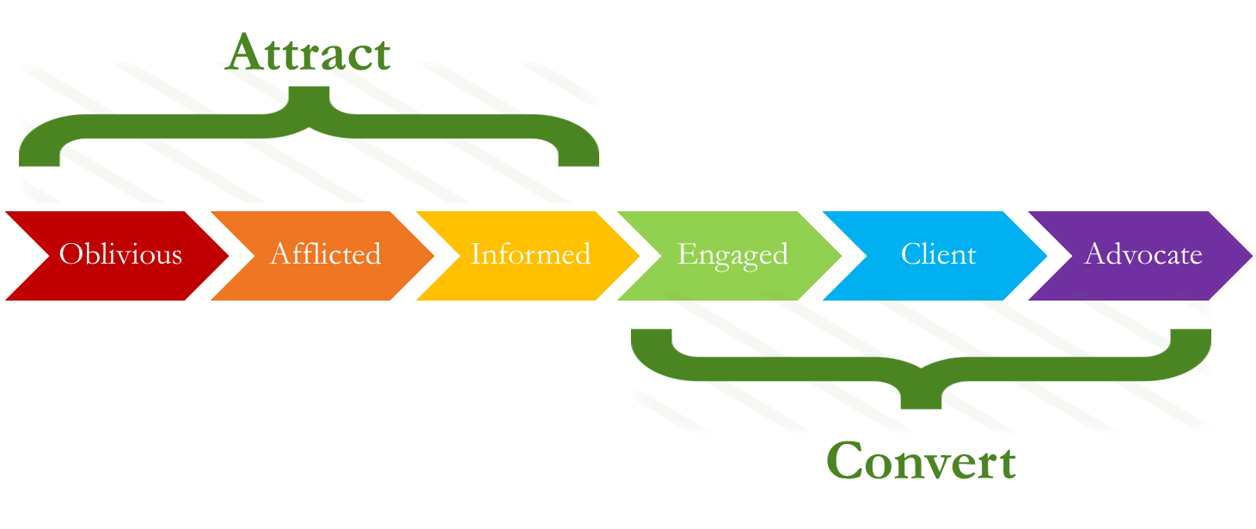

16 facts about consulting sales
- 80% of sales is done before the sell happens
- Sellers that educate are 30% more successful (work with me: collaborate, persuade, listen, understand)
- Sell to the person & problem (successful salespeople discuss solutions later in the conversation)
- Clients buy benefits, not products
- Farming first; Fishing & hunting later.
- Referrals are the best form of sales
- Your seniors should be ‘visible experts’ to attract the right projects
- 71% of clients want to hear from B2B sellers earlier in their ‘problem journey’
- Most buyers aren’t ready to buy when you want to sell, so relationships are key
- Knowledge is no longer a valuable commodity: give away more than you’re comfortable with
- Challenger selling (i.e. credible, confident expert) > Relationship Selling (harmony & agreement)
- Understanding the personality type of the person you’re selling to leads to higher closure rates
- Client value isn’t just efficiency: also buyer value; ease of business; ethics & values;
- 65% of clients are ignorant of the suite of services their consultancies offer
- Successful consultancies market to existing clients as much as new ones
- 72% of clients didn’t refer their consultants because they hadn’t been asked (properly!)

